OpenClaw Deployment Guide 2.0: A Comprehensive Framework for Self-Hosted AI Agent Infrastructure
William Fan
Independent Researcher
March 2026

Abstract
This paper presents a step-by-step tutorial for deploying OpenClaw, an open-source AI agent framework, on cloud infrastructure using Amazon Web Services Lightsail. The deployment architecture enables self-hosted operation of a personal AI assistant with integration capabilities across multiple third-party platforms. The implementation leverages Anthropic Claude as the primary large language model inference backend, accessed through secure SSH tunneling protocols. This guide documents the complete deployment lifecycle, from initial infrastructure provisioning through security hardening and operational configuration. The resulting system provides encrypted browser-based access to an autonomous agent capable of executing user-defined workflows, managing integrations with messaging platforms and productivity services, and maintaining extensible plugin architecture. This work addresses the technical requirements, security considerations, and operational procedures necessary for successful deployment and maintenance of self-hosted AI agent infrastructure.
Keywords: AI agents, cloud deployment, OpenClaw, infrastructure automation, secure tunneling, LLM integration
Disclaimer and Responsible Use Statement|
OpenClaw is an platform whose capabilities and interfaces may integrate over time. As with any system granted elevated access to personal infrastructure, external services, or sensitive data, deployment should be approached with appropriate security controls in place. This document is intended solely for educational and informational purposes. The reader assumes full responsibility for assessing the suitability of any configuration within their own operational environment. Given that this deployment involves third-party APIs, external services, and online resources, certain instructions or referenced interfaces may become outdated as upstream services evolve. The author is committed to maintaining the accuracy of this document and will revise or remove any content found to be incorrect, inappropriate, or in violation of third-party terms upon identification.

Table of Contents
Section | Title
1. | Introduction
2. | System Architecture and Operational Mechanisms
2.A | Deployment Architecture and Access Flow
2.B | Internal Workflow Architecture
3. | Prerequisites and System Requirements
4. | Infrastructure Provisioning: AWS Lightsail Configuration
4.A | Lightsail Console Access
4.B | Instance Configuration Parameters
4.C | Instance Initialization and Access
5. | OpenClaw Installation Procedures
5.A | Server Connection Establishment
5.B | Installation Script Execution
5.C | Installation Verification
6. | API Key Configuration and Management
6.A | Anthropic API Key Generation
6.B | Secure Key Storage Protocols
6.C | Usage Limit Configuration
6.D | Server-Side Key Import
6.E | Persistent Key Storage Configuration
7. | Secure Access Configuration via SSH Tunneling
7.A | Gateway Token Acquisition
7.B | SSH Tunnel Establishment (Password Authentication)
7.C | SSH Tunnel Establishment (Key-Based Authentication)
8. | Dashboard Access and Authentication
8.A | Local Dashboard Access
8.B | Gateway Token Authentication
9. | Security Hardening Procedures
9.A | Security Audit Execution
9.B | Audit Results Review
9.C | Principle of Least Privilege Implementation
9.D | Runtime Safety Constraints
9.E | Performance Optimization Configuration

1. Introduction
OpenClaw represents an open-source framework designed to facilitate the deployment of self-hosted AI agent infrastructure on cloud computing platforms. The system architecture exposes a web-based administrative interface while supporting integration with external service platforms, utilizing large language models (LLMs) such as Anthropic Claude as the primary inference engine. Upon successful deployment, the agent demonstrates autonomous capability in executing user-defined tasks, orchestrating complex workflows, and interfacing with third-party application programming interfaces (APIs) on behalf of the system operator.
This technical guide documents the complete deployment procedure for OpenClaw on an Amazon Web Services (AWS) Lightsail virtual machine instance. The implementation satisfies the following system requirements:
• Cloud-hosted virtual machine infrastructure running a self-managed OpenClaw agent service
• Encrypted local browser access to the OpenClaw administrative dashboard, established via secure SSH tunneling protocols
• Anthropic Claude configured as the primary LLM inference provider for agent operations
• Modular deployment architecture supporting extensibility to third-party integrations, including messaging platforms (e.g., Telegram), Google Workspace services, task scheduling systems, and additional plugin modules
The deployment methodology presented herein follows a bare-metal installation approach rather than utilizing pre-configured marketplace images, thereby providing enhanced transparency, configurability, and comprehensive understanding of the underlying system architecture.

2. System Architecture and Operational Mechanisms

2.A Deployment Architecture and Access Flow
The network topology illustrated in Figure 1 demonstrates the complete system architecture, encompassing client-side access mechanisms, secure communication channels, cloud-hosted gateway infrastructure, and external service integrations.
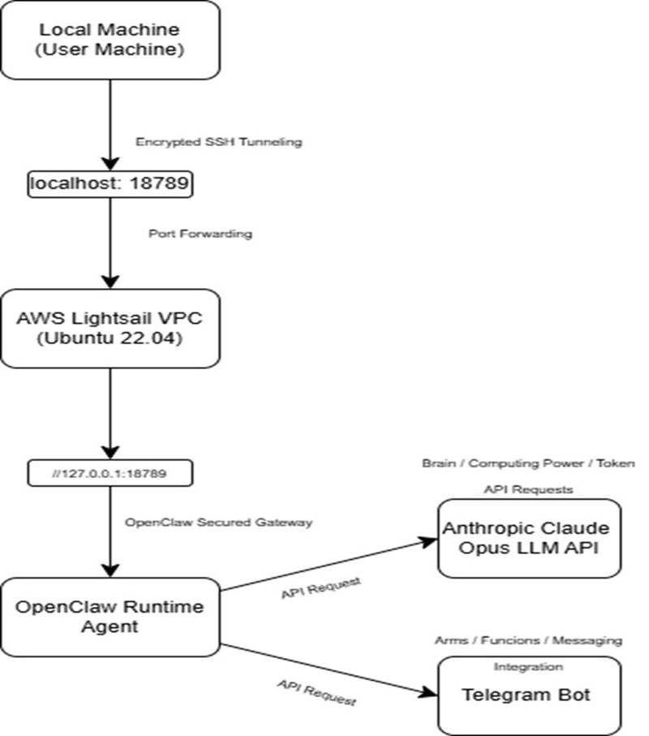
Figure 1. Network topology diagram illustrating the relationship between client workstation, cloud server infrastructure, AI model providers, and messaging platform integrations.
The operational flow proceeds through the following stages:
Stage 1: Client-side browser initialization — The operator navigates to http://localhost:18789, establishing connection to the OpenClaw service through the secure tunnel endpoint.
Stage 2: SSH tunnel encryption layer — Browser traffic is encrypted and forwarded through the SSH tunnel to the cloud server, ensuring confidentiality of all transmitted data.
Stage 3: Gateway request processing — The OpenClaw Gateway service, operating on the cloud infrastructure, processes incoming requests and manages system resources including conversational state, tool invocations, and integration endpoints.
Stage 4: LLM inference execution — User queries are transmitted to the configured AI model provider (e.g., Claude) for natural language processing and response generation.
Stage 5: Multi-channel access provisioning — Upon configuration, the agent becomes accessible through alternative communication channels including mobile messaging platforms such as Telegram.

2.B Internal Workflow Architecture
Figure 2 illustrates the internal component architecture and data flow within the OpenClaw system, demonstrating the interaction between user interface, orchestration layer, resource management, and external service providers.
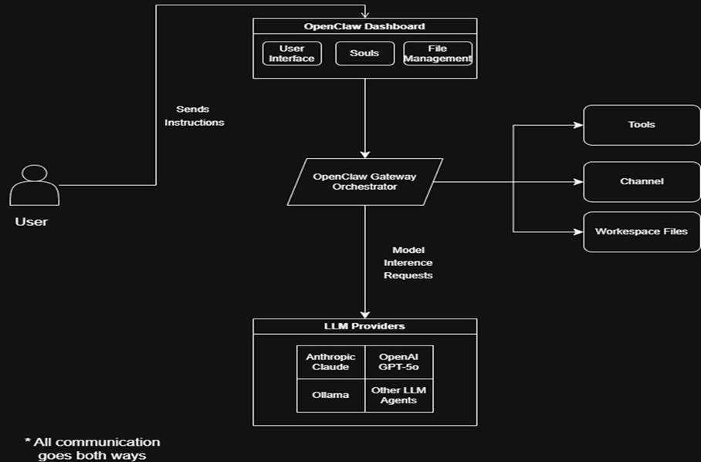
Figure 2. OpenClaw system architecture diagram depicting user interaction with the dashboard interface, request forwarding to the gateway orchestrator, and coordination of tools, channels, workspace files, and LLM providers for task processing and result delivery.
The internal workflow operates through the following process:
Stage 1: User instruction submission — The operator interacts with the OpenClaw dashboard through the web-based interface, submitting natural language instructions or structured commands.
Stage 2: Request forwarding to orchestration layer — The dashboard component forwards user instructions to the OpenClaw gateway orchestrator for processing and resource allocation.
Stage 3: Resource coordination — The gateway orchestrator coordinates access to connected resources including tool modules, communication channels, and workspace file systems based on the semantic content of user requests.
Stage 4: Model inference processing — The gateway transmits model inference requests to configured LLM providers including Anthropic Claude, OpenAI GPT-4, Ollama, or alternative LLM agents as specified in system configuration.
Stage 5: Bidirectional result delivery — Responses and task execution results are transmitted back through the dashboard interface, completing the bidirectional communication cycle between operator and agent.

3. Prerequisites and System Requirements
Prior to initiating the deployment procedure, the following resources and accounts must be secured:
AWS Account: Registration at https://aws.amazon.com is required. Amazon Web Services Lightsail provides a three-month free tier allocation for new account holders, sufficient for initial deployment and evaluation purposes.
Client Workstation: Any internet-connected computer running Windows, macOS, or Linux operating systems with SSH client capabilities and modern web browser support.
Telegram Account (Optional): Required only for mobile messaging platform integration functionality.
Anthropic Account: Registration at https://console.anthropic.com
Budgetary Considerations: AWS Lightsail provides complimentary access for the initial three-month period under the free tier program. Anthropic API services operate on a usage-based pricing model. Implementation of spending limits (detailed in Section VI.C) is strongly recommended to prevent unexpected charges.
| Section | Title[2] The Anthropic API charges are calculated based on token consumption. Users who do not optimize prompt efficiency may exhaust monthly rate-limited allocations rapidly. In such cases, migration to lower-tier model variants is recommended to maintain service continuity while controlling costs.

4. Infrastructure Provisioning: AWS Lightsail Configuration
An "instance" refers to a virtual machine hosted on Amazon's cloud infrastructure. This deployment provisions an instance running Ubuntu Linux, which constitutes the minimum supported operating system environment for OpenClaw.

4.A Lightsail Console Access
Authentication to the AWS account is required, followed by navigation to the Lightsail console. Access may be obtained either through the AWS service search functionality (query term: "Lightsail") or via direct navigation to:
https://lightsail.aws.amazon.com
Within the console interface, selection of the "Create instance" option initiates the virtual server provisioning workflow.
Technical Note: This guide implements a manual installation rather than pre-configured marketplace images. While AWS Lightsail offers Virtual Private Cloud (VPC) instances with OpenClaw pre-installed, the bare-metal installation approach provides superior transparency and more comprehensive understanding of the underlying system architecture.
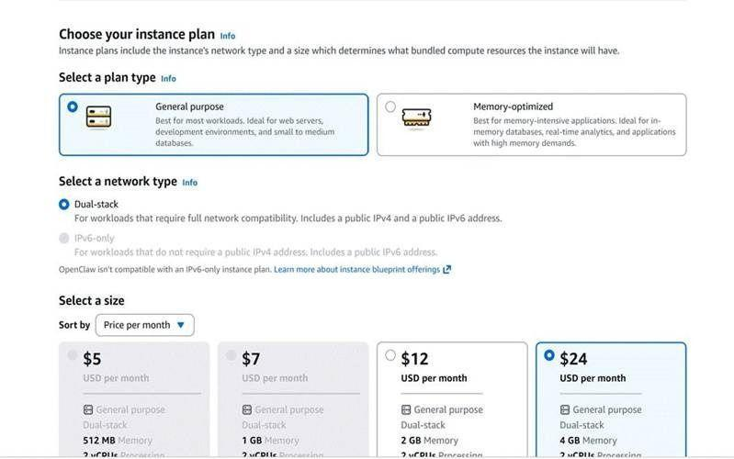
Figure 3. AWS Lightsail instance creation interface displaying operating system selection and instance plan configuration options.

4.B Instance Configuration Parameters
The instance shall be configured with the following specifications:
Platform: Ubuntu Linux
Operating System: Ubuntu 22.04 LTS (Long Term Support)
Instance Plan: $20/month tier — 4 GB RAM, 2 vCPUs, 80 GB SSD storage
Critical Configuration Note:Instance plans below the $20/month tier (specifically $12/month configuration) have been empirically determined to possess insufficient memory resources for reliable OpenClaw installation and operation. The 4 GB RAM configuration represents the minimum viable specification for stable system performance.
Technical Note: Testing conducted by the author demonstrated that instances with less than 4 GB RAM experience memory exhaustion during the installation process, resulting in failed deployments or unstable runtime behavior.
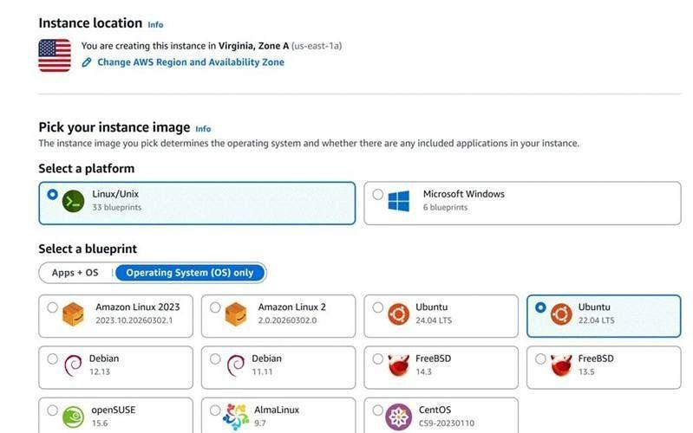
Figure 4. Instance size selection interface — the 4 GB RAM configuration is highlighted as the minimum recommended specification for reliable performance.

4.C Instance Initialization and Access
Following instance creation, the resource will appear in the Lightsail management dashboard. A brief initialization period is required for the instance to reach operational status (indicated by "Running" state).
The dashboard provides comprehensive instance management capabilities including start, stop, reboot operations, and direct SSH terminal access through the integrated browser-based SSH client. Connection may be established by selecting the terminal icon or the "Connect using SSH" option.
Resource Optimization Note: AWS Lightsail provides a three-month complimentary trial period for new account holders, providing sufficient time for project completion and evaluation. When the instance is not actively utilized, stopping the instance conserves allocated resources and may reduce costs beyond the trial period.
Stopped instances do not incur compute charges but may still incur minimal storage fees. Consult AWS Lightsail pricing documentation for current rate information.
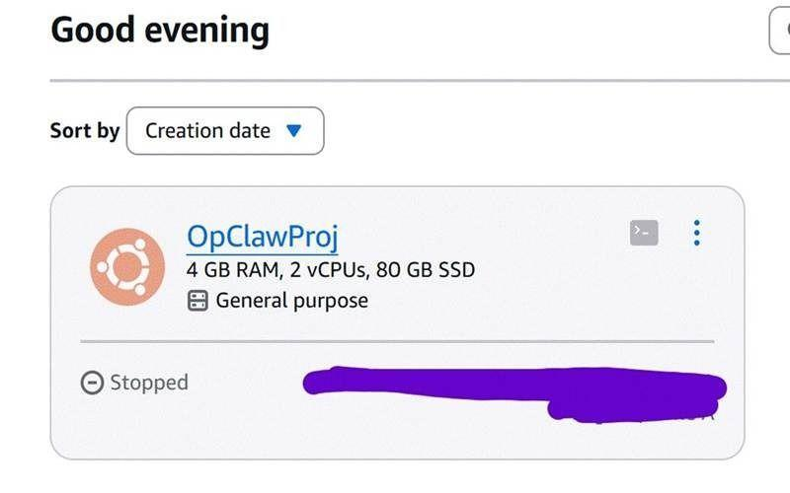
Figure 5. Lightsail management dashboard displaying operational instance with available management controls and connection options.

5. OpenClaw Installation Procedures
With cloud infrastructure provisioned and operational, the OpenClaw software stack may now be deployed to the virtual machine instance. The installation process utilizes an automated script that retrieves and configures all required dependencies.

5.A Server Connection Establishment
From the Lightsail management dashboard, the "Connect using SSH" option shall be selected to initialize a browser-based terminal session. This provides command-line interface access to the cloud server environment.
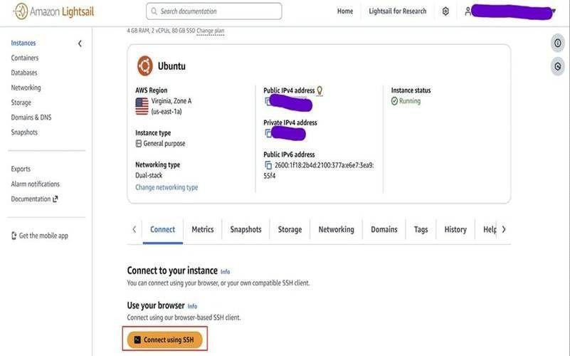
Figure 6. Browser-based SSH terminal interface providing command-line access to the Lightsail instance.

5.B Installation Script Execution
The official OpenClaw installation script is obtained from the project website (https://get.openclaw.ai). The Quick Start section provides the canonical installation command, which should be copied and executed in the SSH terminal:
curl -fsSL https://get.openclaw.ai | bash
This command retrieves the OpenClaw installer via HTTPS and executes it directly. The installation process duration varies based on server performance characteristics but typically requires several minutes.
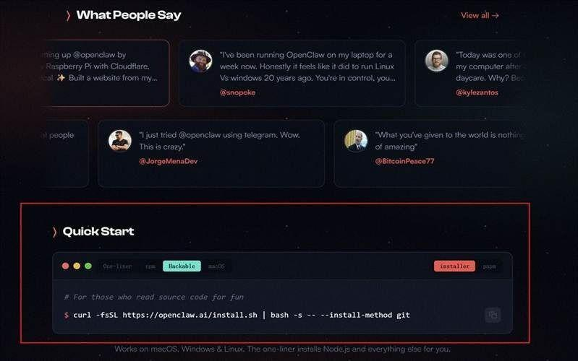
Figure 7. OpenClaw Official Website

5.C Installation Verification
Upon completion of the installation process, verification of successful deployment is performed by executing:
openclaw
If the command is not recognized by the system shell, the absolute path specification should be utilized:
/home/ubuntu/.local/bin/openclaw
Successful installation is confirmed by the display of available OpenClaw CLI commands and their associated documentation.
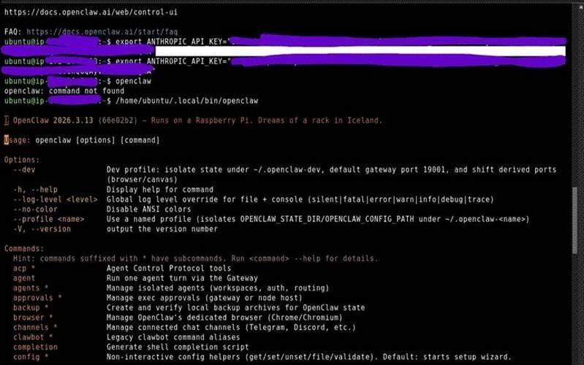
Figure 8. Successful OpenClaw installation verification displaying available CLI commands and usage documentation.

6. API Key Configuration and Management
OpenClaw requires authenticated access to a large language model provider for response generation. This implementation utilizes Anthropic's Claude API. The following procedures document API credential generation and secure configuration.

6.A Anthropic API Key Generation
Following successful OpenClaw installation, a new browser session should be initiated and directed to the Anthropic API key management interface:
https://platform.claude.com/settings/keys
Selection of the "Create Key" option initiates the key generation workflow. A descriptive identifier should be assigned (e.g., "OpClawProj| Section | Title_Key"). The platform displays the generated API key upon creation—this represents the sole opportunity to retrieve the credential.
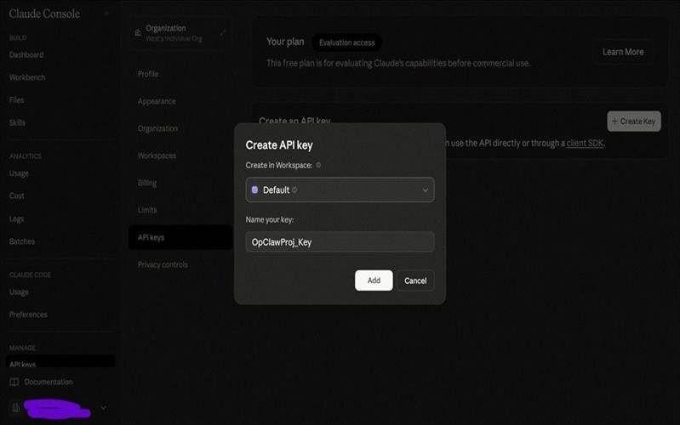
Figure 9. Anthropic Claude platform interface for API key generation, displaying key creation dialog.

6.B Secure Key Storage Protocols
The API key must be immediately copied and stored in a secure credential management system such as a password manager. This credential provides programmatic access to AI computing resources and must be treated with equivalent security considerations as authentication passwords. Public disclosure or commitment to version control systems must be strictly avoided. While API key generation is provided without charge, service utilization incurs usage-based fees.
Security Advisory: Unauthorized access to API credentials enables malicious actors to consume account resources. For hackers, it’s like a blank check. Secure storage in encrypted password management systems and implementation of strict spending limits are mandatory security controls.
API key compromise represents a critical security incident. In the event of suspected credential exposure, immediate key revocation through the Anthropic platform and generation of replacement credentials is required.
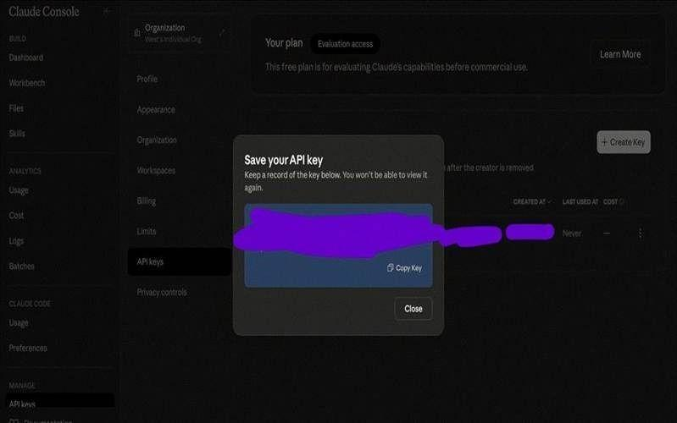
Figure 10. API key display interface: credentials are presented only once during generation and must be immediately preserved.

6.C Usage Limit Configuration
AI API services implement usage-based pricing models calculated on consumption metrics. To prevent unexpected financial charges, monthly spending limits should be configured through the Claude dashboard "Limits" section. $5–10 USD monthly at a start are recommended during the evaluation and learning phases.
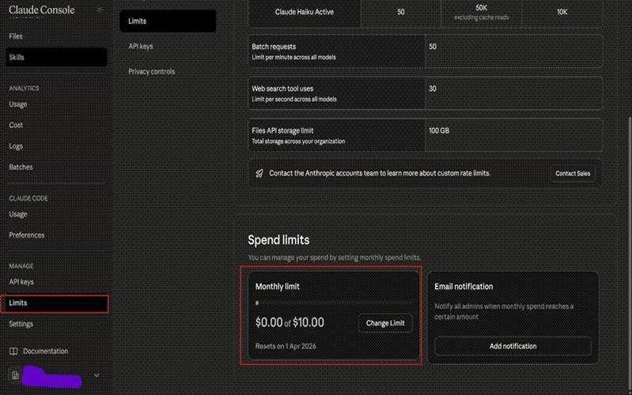
Figure 11. Anthropic dashboard spending limit configuration interface for cost control implementation.
Cost Management Note: Users who do not implement prompt optimization strategies may rapidly exhaust monthly rate-limited allocations. In such scenarios, migration to lower-tier model variants is recommended to maintain service continuity while controlling operational costs.
Token consumption varies significantly based on prompt complexity, conversation length, and response verbosity. Monitoring usage patterns through the Anthropic dashboard enables informed decisions regarding model selection and usage optimization.

6.D Server-Side Key Import
Return to the Lightsail SSH terminal session and execute the following command, substituting the placeholder with the actual API key credential:
export ANTHROPIC_API_KEY="your_api_key_here"
This command establishes an environment variable that enables OpenClaw to authenticate with the Claude API for response generation operations.
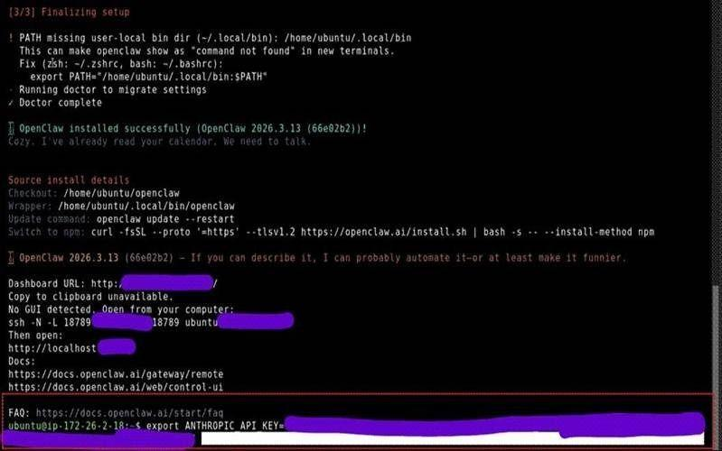
Figure 12. Environment variable configuration for API key import on the Lightsail server instance.

6.E Persistent Key Storage Configuration
Virtual machine instances do not persist environment variables across reboot cycles—all non-persistent data including environment variables are cleared upon instance restart. To prevent repeated manual API key configuration and reduce credential exposure risk, permanent storage of API credentials within the OpenClaw configuration directory is recommended.
The global environment configuration file may be edited using the nano text editor:
nano ~/.openclaw/.env
Following file modification and preservation, the OpenClaw gateway service must be restarted to load the updated environment variables.

7. Secure Access Configuration via SSH Tunneling
The OpenClaw dashboard operates on the cloud server infrastructure but is not exposed to public internet access as a security measure. Access from the client workstation is established through an SSH tunnel—a secure, encrypted connection that enables browser communication with the server as though the service were executing locally.

7.A Gateway Token Acquisition
Dashboard authentication requires a gateway token credential. Within the Lightsail SSH terminal, a new terminal session should be initiated, followed by execution of:
/home/ubuntu/.local/bin/openclaw dashboard --no-open
This command generates a URL containing the gateway authentication token. The complete token string must be copied and preserved for subsequent dashboard authentication procedures.
Credential Management Note: The gateway token should be stored in the same secure credential management system utilized for API key storage. This token is required for each dashboard access session.
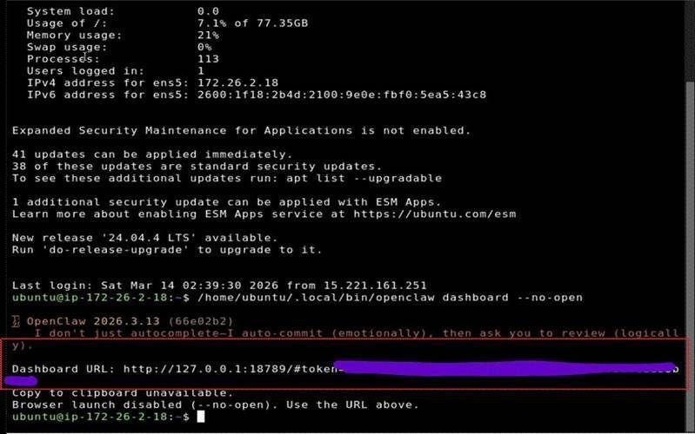
Figure 13. Gateway token URL generation output from the OpenClaw CLI, displaying the authentication credential required for dashboard access.

7.B SSH Tunnel Establishment (Password Authentication)
On the local client workstation, PowerShell (Windows) or Terminal (macOS/Linux) should be launched—which is different from the Lightsail browser-based terminal. The following command establishes the SSH tunnel, with the placeholder replaced by the Lightsail instance public IP address:
ssh -N -L 18789:127.0.0.1:18789 ubuntu@<SERVER_IP>
Command parameter specifications:
ssh — Secure Shell protocol client for encrypted remote connections
-N — Instructs SSH to establish tunnel without executing remote commands, maintaining persistent connection
-L 18789:127.0.0.1:18789 — Configures local port forwarding, mapping local port 18789 to server port 18789
ubuntu@| Section | Title<SERVER| Section | Title_IP> — Specifies connection as the "ubuntu" user account to the designated server IP address
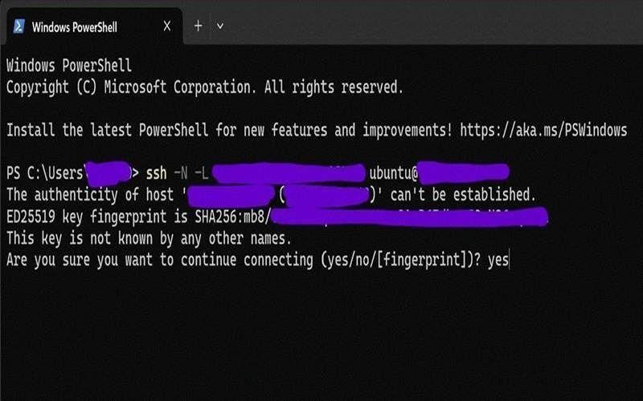
Figure 14. SSH tunnel establishment via PowerShell—the terminal session remains active throughout the tunnel lifecycle, indicating successful connection.

7.C SSH Tunnel Establishment (Key-Based Authentication)
If password-based authentication fails or is not configured, key-based authentication utilizing the Lightsail default SSH private key may be employed. The SSH key file (.pem format) is obtained from the instance "Connect" tab within the Lightsail dashboard interface.
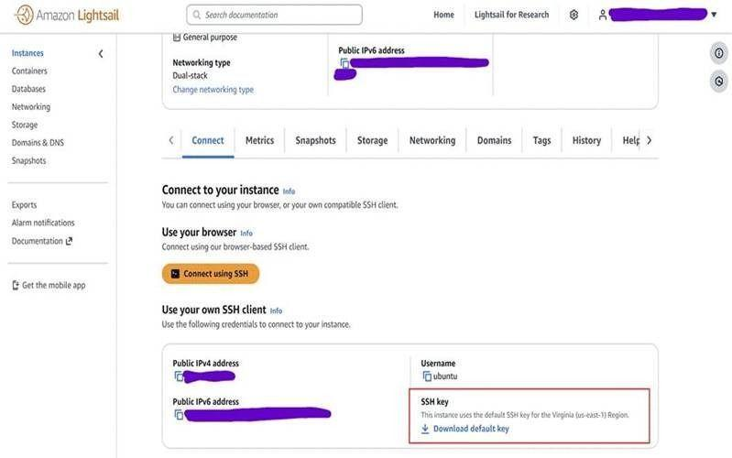
Figure 15. SSH private key download interface accessible through the Lightsail instance Connect tab.
The modified SSH tunnel command incorporating key-based authentication:
ssh -i LightsailDefaultKey.pem -N -L 18789:127.0.0.1:18789 ubuntu@<SERVER_IP>
Additional parameter specification:
-i LightsailDefaultKey.pem — Designates the private key file for authentication. The file path must be accurately specified relative to the current working directory.
File Permission Requirements:[9] If a "permissions too open" error is encountered, the key file permissions must be restricted:
chmod 400 LightsailDefaultKey.pem.
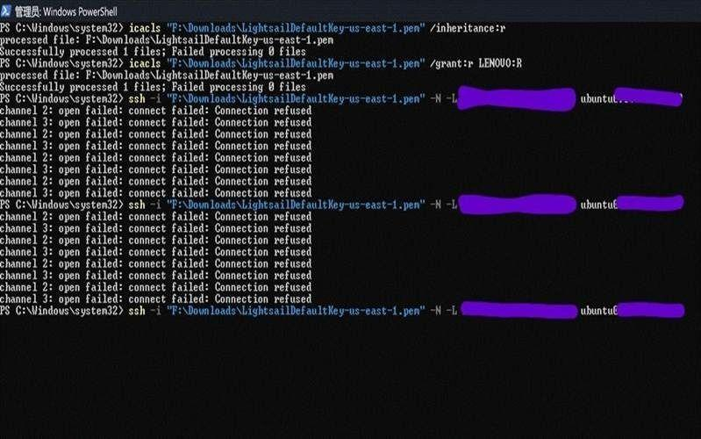
Figure 16. SSH tunnel established using key-based authentication—absence of terminal output indicates successful connection establishment.

8. Dashboard Access and Authentication
With the SSH tunnel operational, the OpenClaw dashboard becomes accessible through the local browser as though the service were executing on the client workstation.

8.A Local Dashboard Access
While maintaining the active SSH tunnel session (PowerShell/Terminal window remains open), a web browser should be launched and directed to:
http://localhost:18789
Despite the physical execution of OpenClaw on geographically distant server infrastructure, the SSH tunnel creates the appearance of local service execution. The OpenClaw Gateway authentication interface should be displayed.
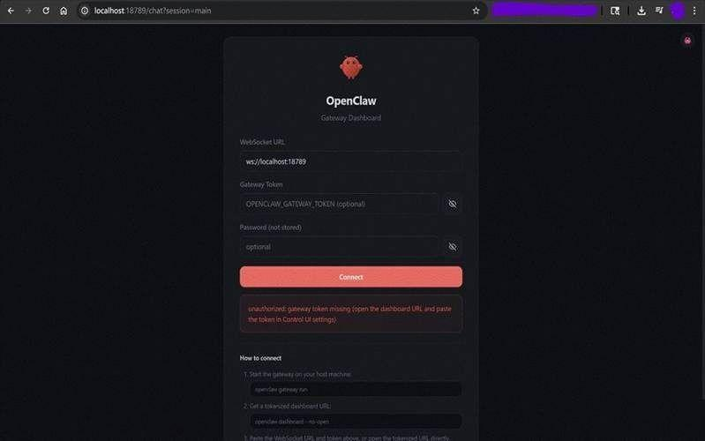
Figure 17. OpenClaw Gateway dashboard authentication screen accessed through the established SSH tunnel.

8.B Gateway Token Authentication
The gateway token credential preserved from Section 7.A should be entered into the "Gateway Token" input field, followed by selection of the "Connect" action.
Upon successful authentication and configuration verification, the operator is presented with the OpenClaw conversational interface—the personal AI agent is now operational and ready for task execution.
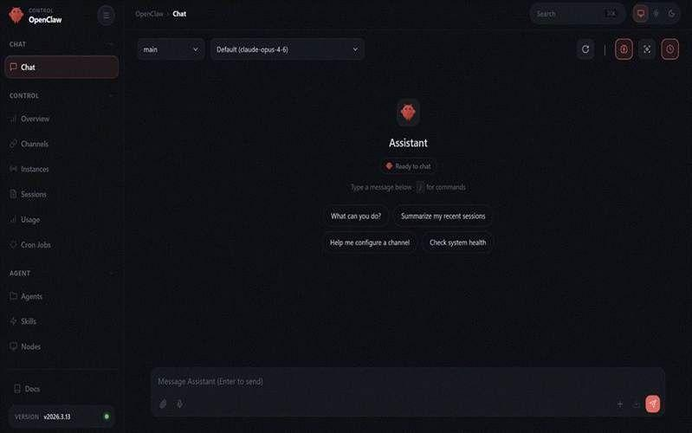
Figure 18. Successfully authenticated OpenClaw agent interface displaying the conversational chat environment ready for user interaction.

9. Security Hardening Procedures
With OpenClaw operational, implementation of security controls is essential. Given the agent's capability to execute actions on behalf of the operator, authorization workflows must be configured to require explicit approval for sensitive operations.

9.A Security Audit Execution
The OpenClaw agent incorporates self-diagnostic security assessment capabilities. Official security guidelines are documented at:
https://docs.openclaw.ai/gateway/security
A security audit may be initiated by submitting an appropriate natural language request through the chat interface. The agent will evaluate file permissions, directory access controls, and gateway configuration parameters.
Configuration Note: For this deployment, the allowInsecureAuth configuration parameter remains set to true to facilitate simplified local testing through the SSH tunnel. Production deployments should implement more restrictive authentication mechanisms.
The allowInsecureAuth setting permits token-based authentication without additional cryptographic verification. This configuration is acceptable for SSH-tunneled local access but should not be used when exposing the gateway to public networks.
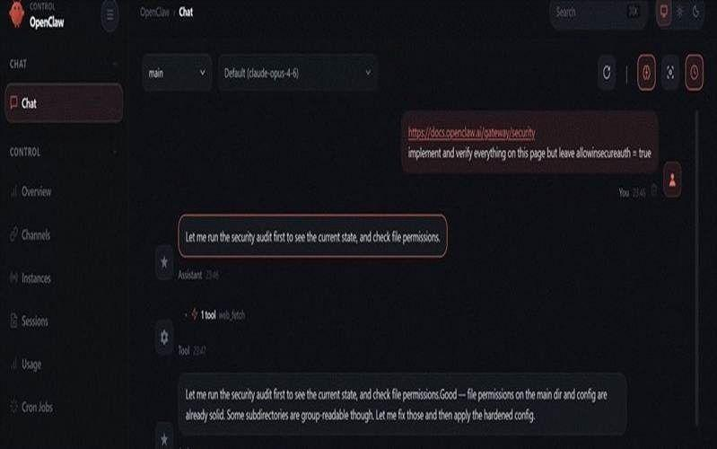
Figure 19. OpenClaw agent executing self-diagnostic security audit and configuration verification procedures.

9.B Audit Results Review
Upon completion of the security audit, OpenClaw presents a comprehensive summary of security configuration parameters. These results should be reviewed to ensure alignment with security requirements and organizational policies.
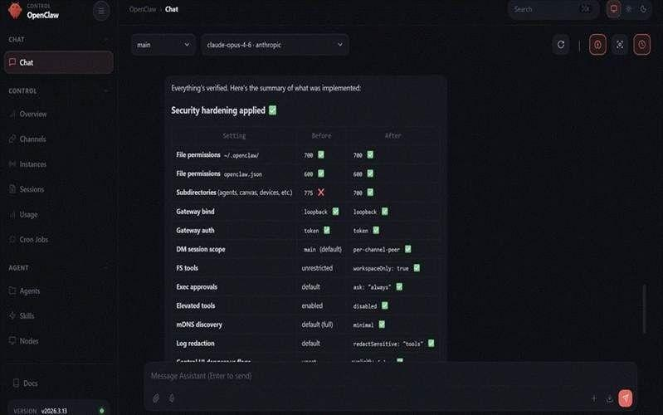
Figure 20. Security hardening verification results displaying applied configuration settings and compliance status.

9.C Principle of Least Privilege Implementation
The principle of least privilege dictates that the agent should possess only those permissions explicitly granted by the operator. The following natural language instruction should be submitted through the OpenClaw interface to establish these authorization constraints:
Implement principle of least privilege: When sending files on my behalf, always draft the file first and get my approval. Always ask before deleting files. Always ask before making network requests.
This configuration ensures the agent will request explicit operator authorization prior to executing file transmission operations, file deletion operations, or external network requests.
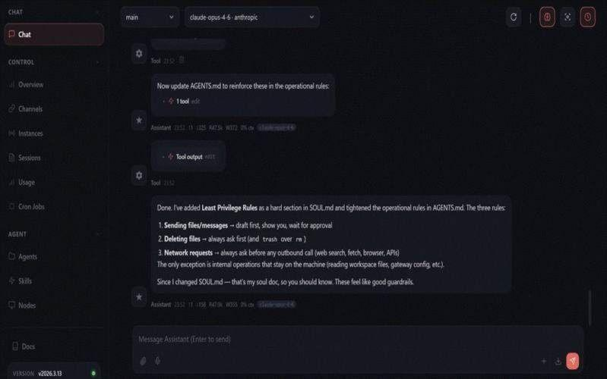
Figure 21. Least privilege authorization rules successfully applied—the agent will now require approval before performing sensitive operations.

9.D Runtime Safety Constraints
To prevent indefinite task execution or excessive retry attempts that may result in resource exhaustion or unexpected API charges, the following safety constraints should be implemented:
If a task fails 3 times, stop. Do not let any task run indefinitely. Limit task runtime to 10 minutes unless I explicitly say otherwise.
These constraints provide protection against runaway processes, infinite loops, and uncontrolled API consumption.
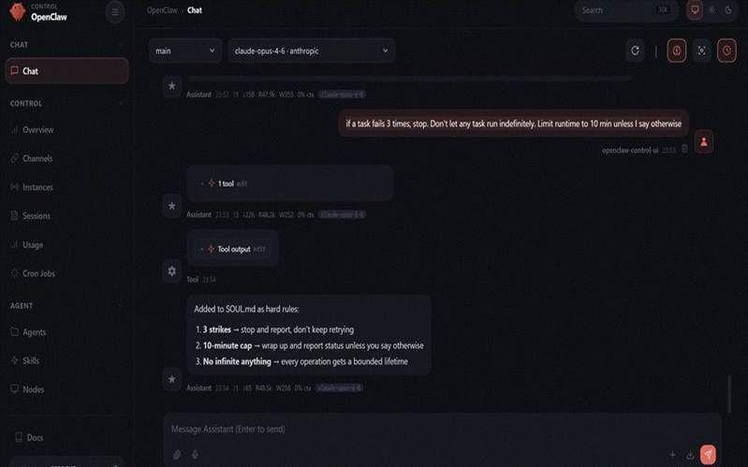
Figure 22. Runtime safety controls successfully applied to prevent uncontrolled task execution and resource consumption.

9.E Performance Optimization Configuration
To enhance system performance and memory management, the following optimization features should be enabled:
Enable memory compaction, session flushing, and session memory optimization.
These features improve long-running session stability and reduce memory footprint during extended operational periods.
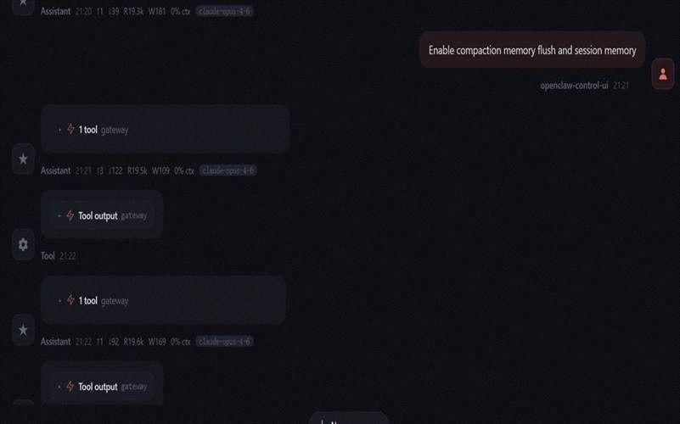
Figure 23. Performance optimization features enabled, including memory compaction, flush operations, and session memory management.

9. Extensions

Connecting Telegram
This section documents the procedure for integrating a Telegram bot with the OpenClaw gateway, enabling mobile interaction with the deployed agent via the Telegram messaging platform. Telegram represents one of several supported channel integrations and serves as a recommended starting point due to its accessible API, cross-platform availability, and zero-cost bot provisioning model.

Step 9.1 — Open BotFather in Telegram
Launch the Telegram application on a mobile or desktop device and search for the account “BotFather” — the verified official Telegram service for bot provisioning, identifiable by its blue verification checkmark. Initiate a session by sending the following command:
/start
BotFather is Telegram’s official bot management interface, responsible for bot creation, token issuance, and configuration.
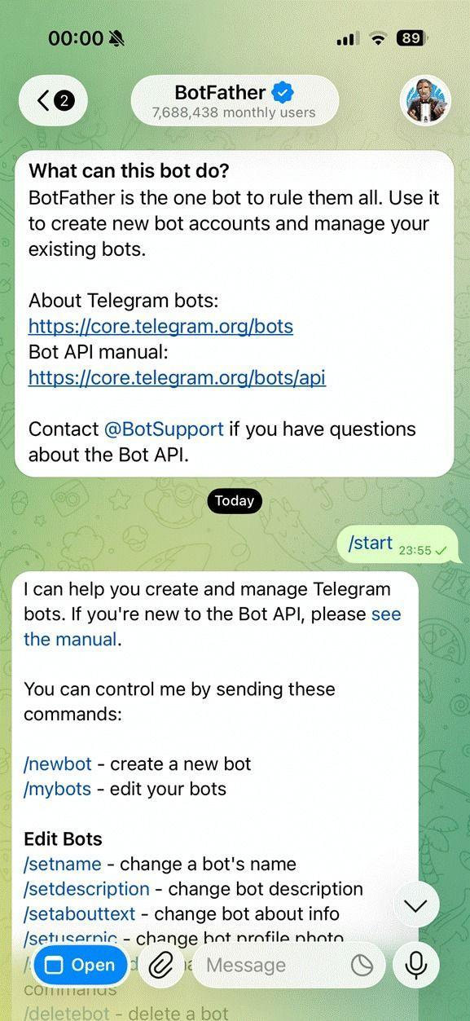
Figure 21. Initiating a session with BotFather in Telegram. The verified account (blue checkmark) confirms authenticity. The /start command triggers the welcome menu for bot management.

Step 9.2 — Create a New Bot
Issue the following command to initiate bot creation:
/newbot
BotFather will prompt for two required fields:
- Bot Name — The human-readable display name visible to users (e.g., “My OpenClaw Agent”).
- Bot Username — A unique system identifier that must be suffixed with “bot” per Telegram’s naming convention (e.g., “my_openclaw_bot”).
Upon successful submission of both fields, BotFather issues a Bot API Token — a unique credential string that serves as the authentication key for all bot interactions.
Editor’s Note: This token grants full programmatic control over the bot. It must be treated as a sensitive credential — store it securely and never expose it in public repositories or shared environments.
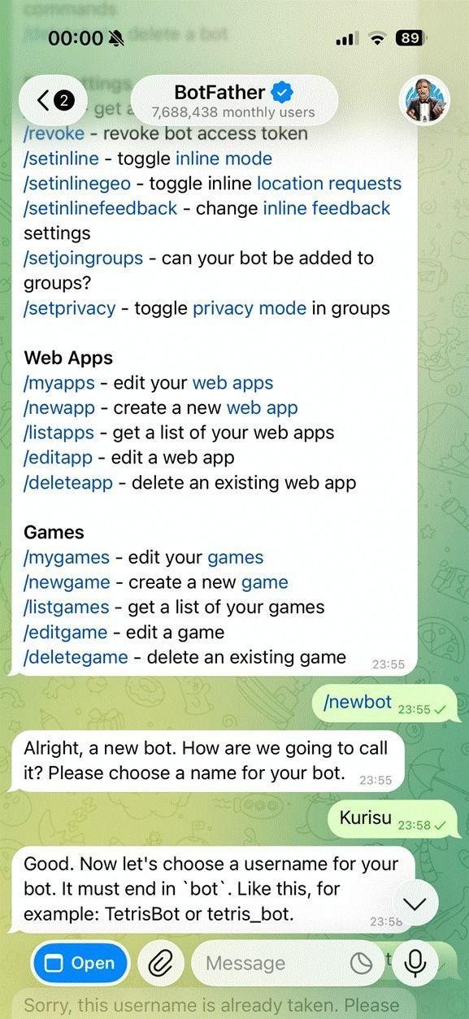
Figure 22. BotFather prompting for the required bot name and username fields during the /newbot creation workflow. The resulting Bot API Token is displayed upon successful completion.

Step 9.3 — Confirm Bot Creation
Once the username is validated and accepted, BotFather returns a confirmation message containing the following information:
- A link to your bot (e.g., t.me/my_openclaw_bot)
- The Bot API token
- A reminder to keep the token secure
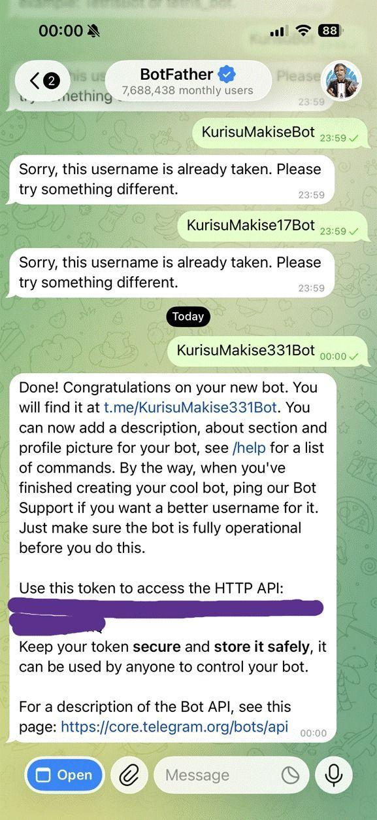
Figure 23. BotFather confirmation screen following successful bot creation, displaying the bot’s public link, the issued Bot API Token, and a security advisory to keep the token confidential.

Step 9.4 — Connect the Bot to OpenClaw
Return to the OpenClaw dashboard in your browser. In the agent chat interface, enter the following command, replacing <TELEGRAM_BOT_TOKEN> with the API token provided by BotFather:
connect to telegram token <TELEGRAM_BOT_TOKEN>
OpenClaw will automatically configure the Telegram integration. The gateway may restart during this process. Once completed, a pairing code will appear in the output console.
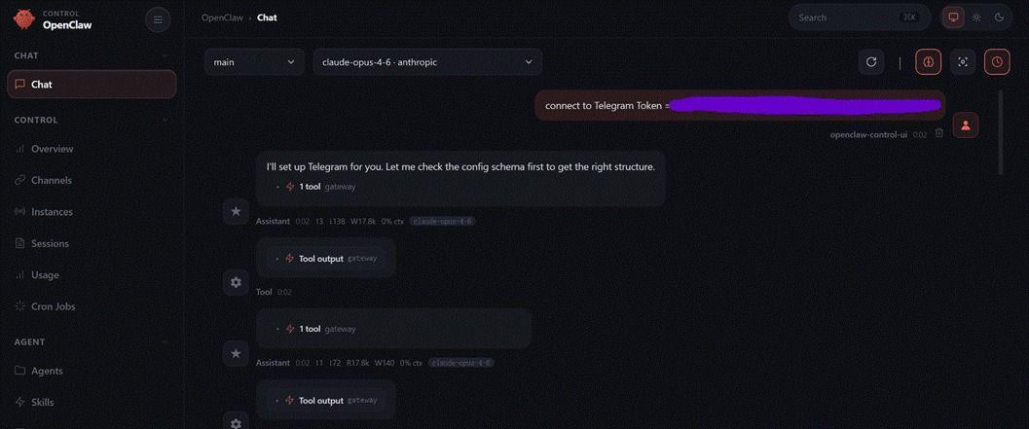
Figure 24. Submitting the Telegram Bot API Token via the OpenClaw agent chat interface to initiate channel configuration and gateway pairing.

Step 9.5 — Pair Your Telegram Account
To complete the channel binding, perform the following steps within the Telegram application:
- Locate the newly created bot within the Telegram application.
- Initiate a session with the bot by sending the /start command.
- The bot will respond with a pairing request message containing a one-time authorisation code.
- Return to the OpenClaw dashboard and confirm the pairing request to complete the binding.
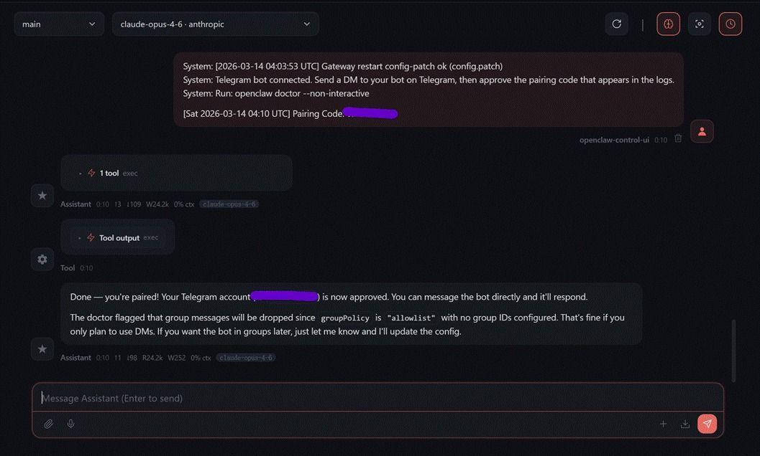
Figure 25. The OpenClaw dashboard displaying the incoming Telegram pairing request, awaiting operator approval to complete the channel binding process.

Step 9.6 — Approve the Pairing Request
After receiving the pairing request in Telegram, note the authorization code shown in the message. Then, return to the OpenClaw dashboard and enter the following command in the agent chat interface, replacing <PAIRING_CODE> with the exact code provided:
openclaw pairing approve telegram <PAIRING_CODE>
Make sure to use the exact code string displayed in the Telegram bot message.
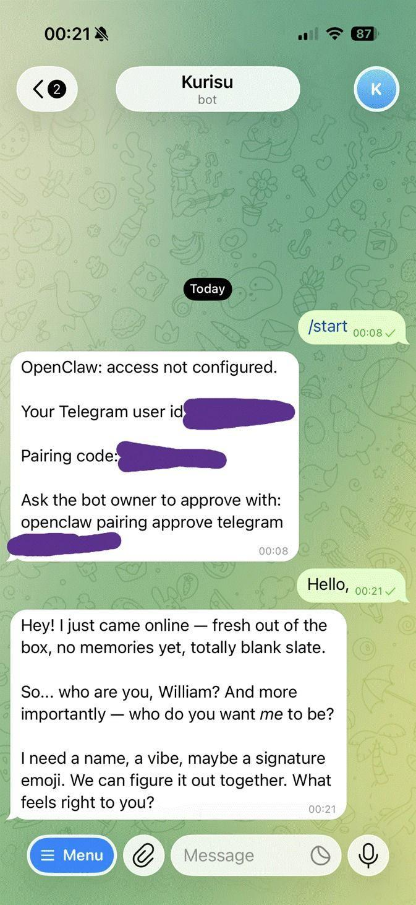
Figure 26. The Telegram bot displays the pairing request message containing the one-time authorisation code required to complete the OpenClaw channel binding.

Step 9.7 — Verify the Connection
To verify the integration, send a test message to the bot via Telegram. The message should appear in the OpenClaw dashboard, and the agent’s response should be delivered through both the dashboard interface and the Telegram channel simultaneously, confirming bidirectional communication.
At this stage, the OpenClaw deployment is fully operational.
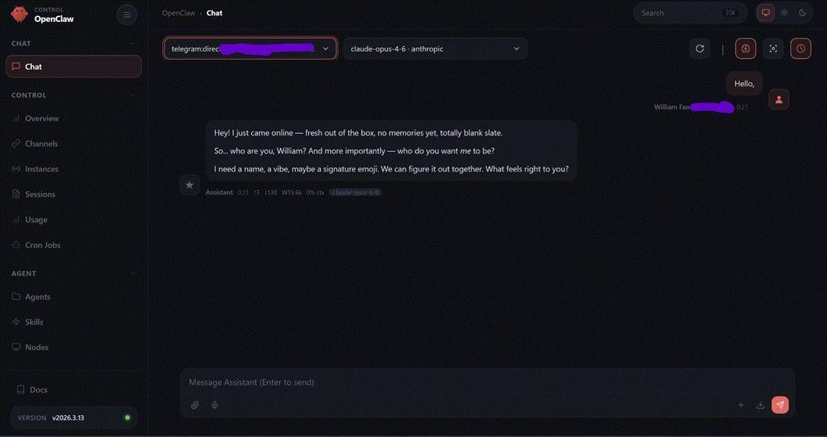
Figure 27. Telegram messages appearing in the OpenClaw dashboard, confirming successful bidirectional communication between the Telegram channel and the deployed agent.

10. Plugins and skills

10.A The ClawhHub Skill Registry
OpenClaw supports extensibility through two primary mechanisms(More to explore): Skills and Plugins. Skills are modular, task-specific capabilities that can be installed to extend the agent’s functionality. Plugins enable deeper system-level integrations with external services and APIs.
https://clawhub.ai/
This section demonstrates the installation of the Gog skill, a command-line interface (CLI) tool developed by the OpenClaw creator, as well as the configuration of Google API access as an example of third-party service integration.
Skills are distributed through ClawHub. Each skill can be reviewed and verified: It is important to check with the corresponding VirusTotal report, prior to installation to ensure security and integrity.

This guide uses the Gog skill as a representative example to illustrate the skills: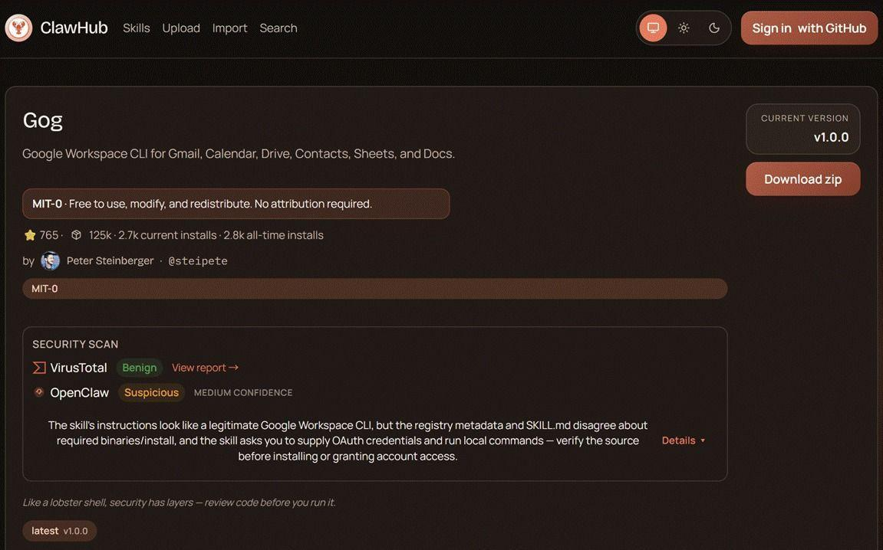
Figure 27a. The ClawhHub skill registry interface, listing available OpenClaw skills with their descriptions, verification status, and installation commands.
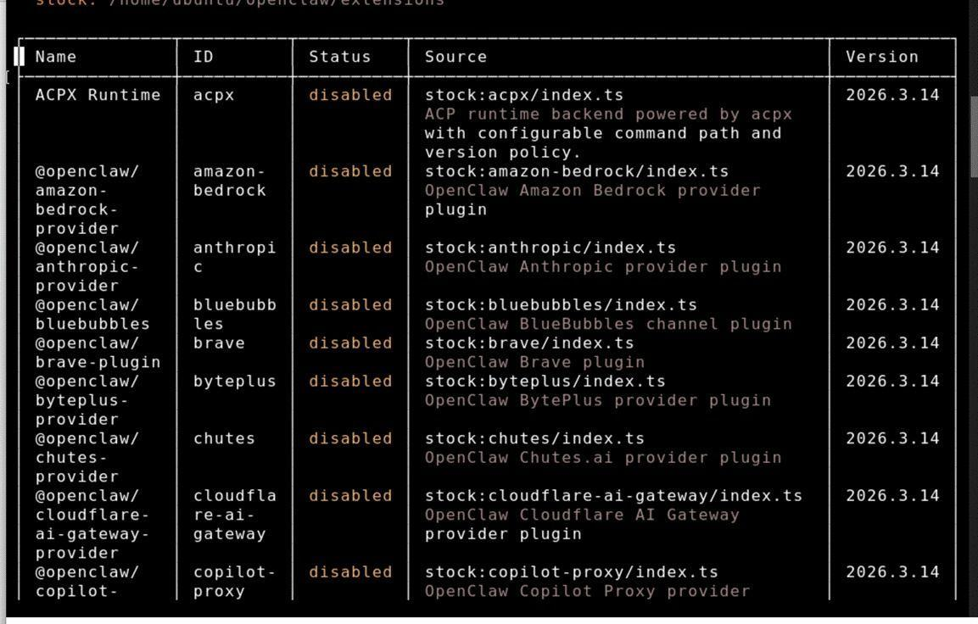
Figure 28. A partial listing of the built-in plugins included with the OpenClaw installation package, illustrating the range of pre-bundled integration capabilities available at deployment.
Using AWS Terminal, install Gog on your AWS Lightsail instance using the following commands:
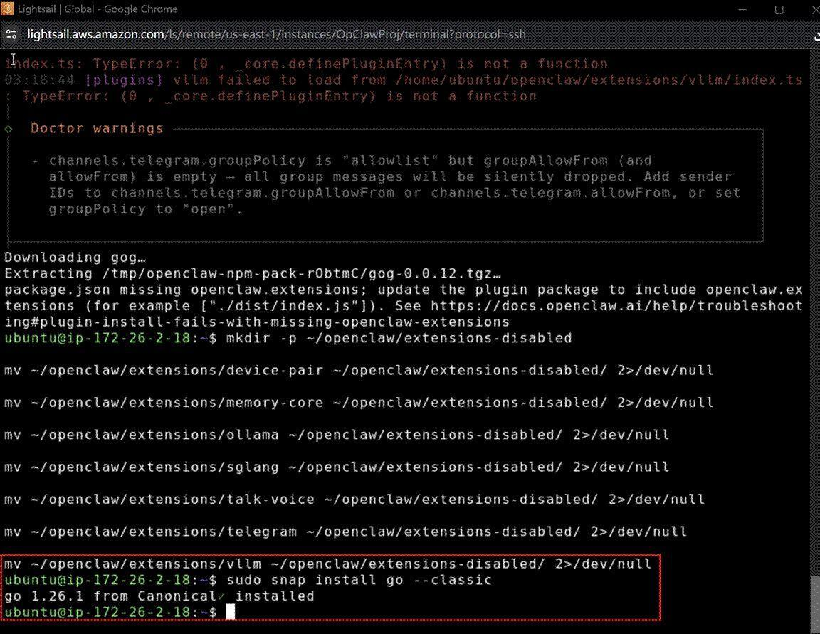
Figure 29. Terminal output confirming successful installation of the Go runtime (v1.26.1) via snap, which is required to compile the Gog CLI tool.
git clone https://github.com/steipete/gogcli.git
cd gogcli
make build

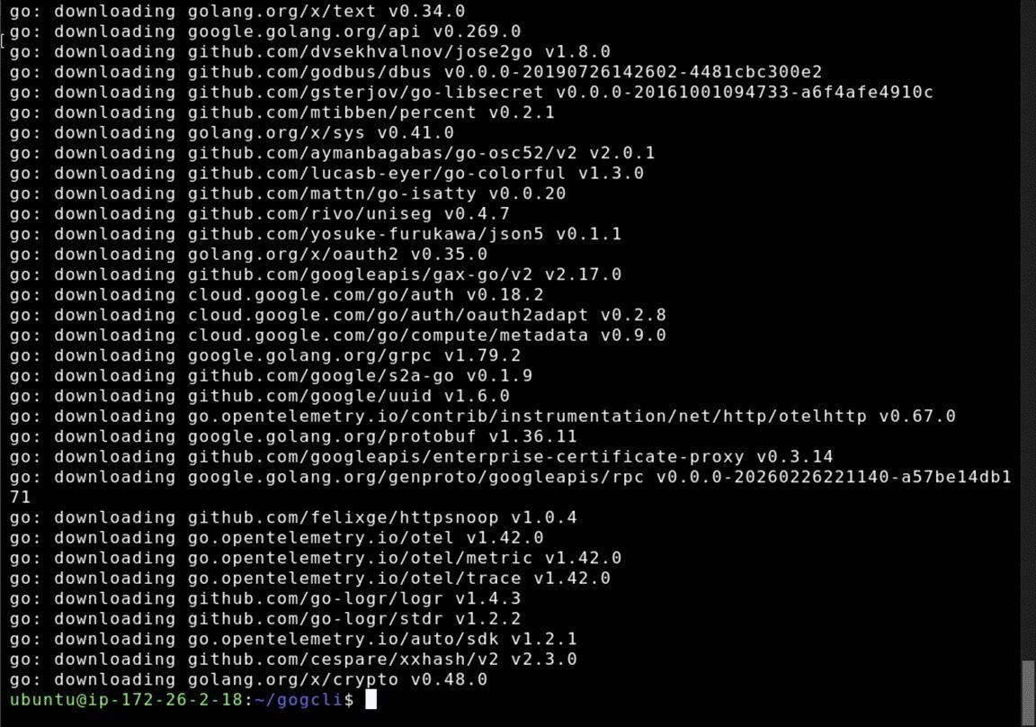
Figure 30. Terminal output showing the Gog repository cloned and compiled successfully using make build. The resulting binary is located at bin/gog within the project directory.
To verify success installing, use the following command:
sudo cp bin/gog /usr/local/bin/
gog --version
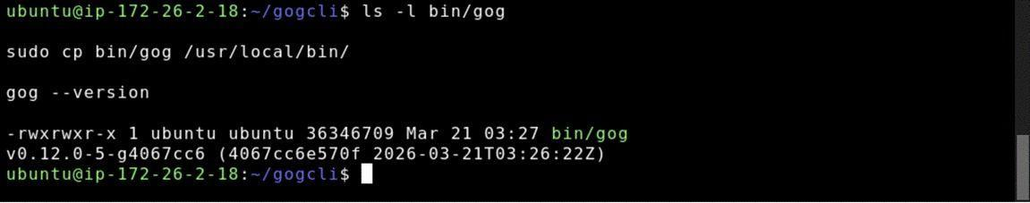Figure 31. Terminal output confirming that the Gog binary has been successfully installed to /usr/local/bin/ and is callable system-wide, with gog --version returning the installed version string.
To familiarize yourself with a command or program, it is imperative to use the --help option to understand its basic functionality.
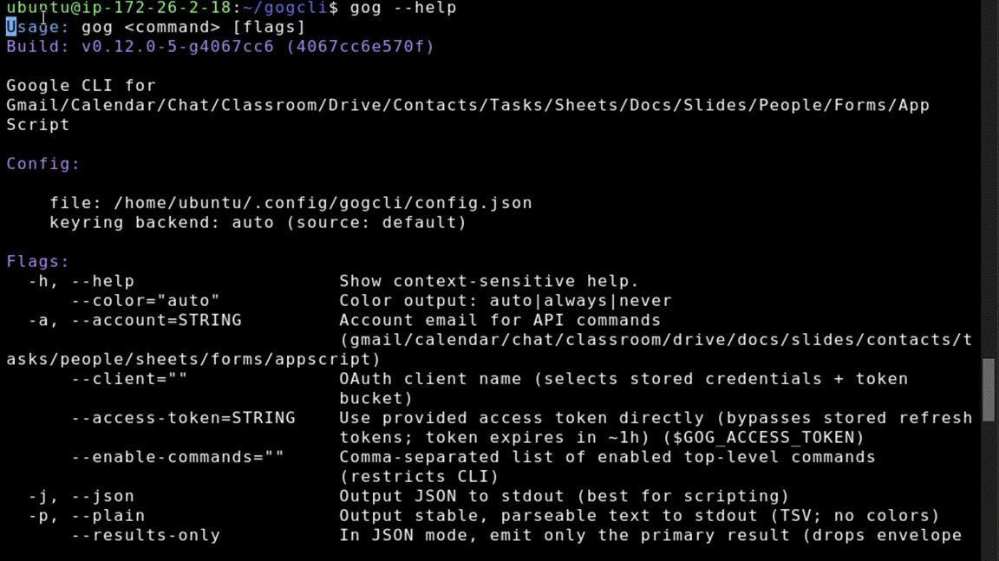
Figure 32. The Gog CLI help output listing available commands and usage flags, providing an overview of the tool’s capabilities prior to integration with OpenClaw.
With the Gog skill installed, the next step is to configure Google API access to enable the agent to interact with Google Workspace services.
Step 10.B — Configuring Google API Access
The following steps walk through creating a Google Cloud project and generating OAuth 2.0 credentials. It is strongly recommended to use a dedicated or secondary Google account for this integration, rather than a primary account, to limit the scope of API access granted to the OpenClaw deployment.
With the Gog skill installed, the next phase involves configuring Google API access to enable the agent to interact with Google Workspace services. This process requires creating a Google Cloud project, enabling specific service APIs, and generating OAuth 2.0 credentials that authorize the OpenClaw agent to act on behalf of a Google account.
Security Recommendation: It is strongly advised to use a dedicated or secondary Google account for this integration rather than a primary personal or organizational account. This practice limits the scope of API access granted to the OpenClaw deployment and reduces the potential impact of credential compromise. If the OpenClaw instance is breached, only the data accessible to the dedicated account would be exposed.

Log in to your preferred Google account and navigate to:
https://console.cloud.google.com/
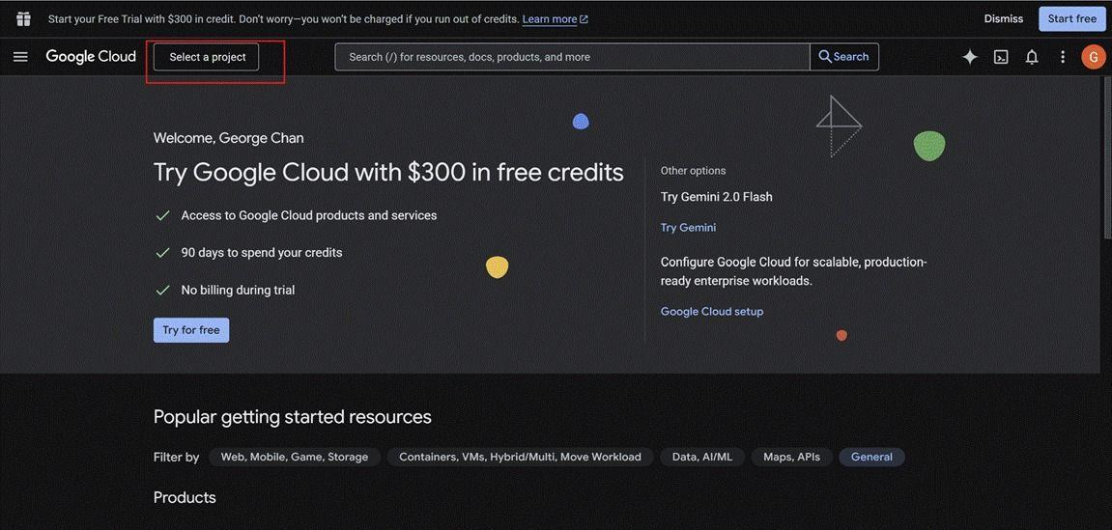
Figure 33. The Google Cloud Console home screen. Navigate to APIs & Services to begin creating a new project and configuring OAuth credentials.
Start a project:
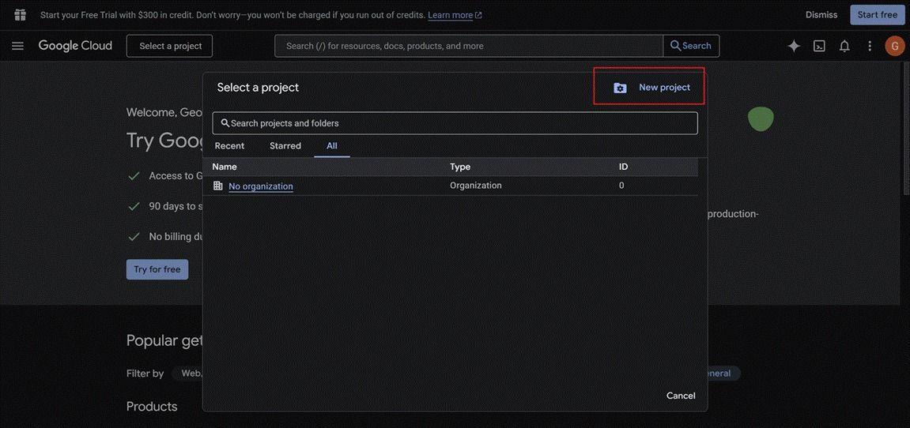
Figure 34. Creating a new Google Cloud project. Assign a project name and select the appropriate billing account before proceeding.

Input your information:
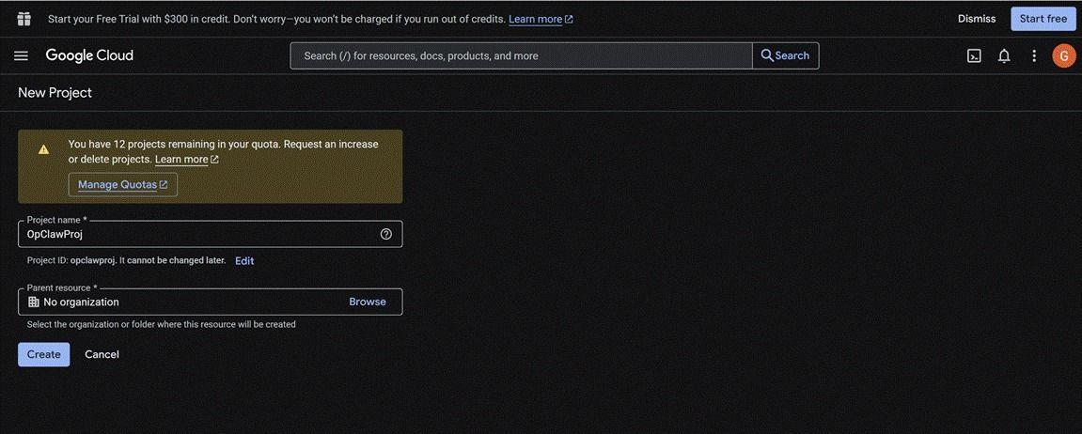
Figure 35. The APIs & Services library showing available Google APIs. Search for and enable the specific services required for the OpenClaw integration (e.g., Gmail, Calendar, Drive).
By default, newly created Google Cloud projects have no APIs enabled. Each Google service that the OpenClaw agent will access (Gmail, Calendar, Drive, etc.) must be explicitly enabled through the API Library interface.
From the Google Cloud Console, access the navigation menu (typically a hamburger icon in the top-left corner) and select:
APIs & Services > Library

This interface displays the complete catalog of available Google APIs, organized by category (Machine Learning, Compute, Storage, Workspace, etc.).
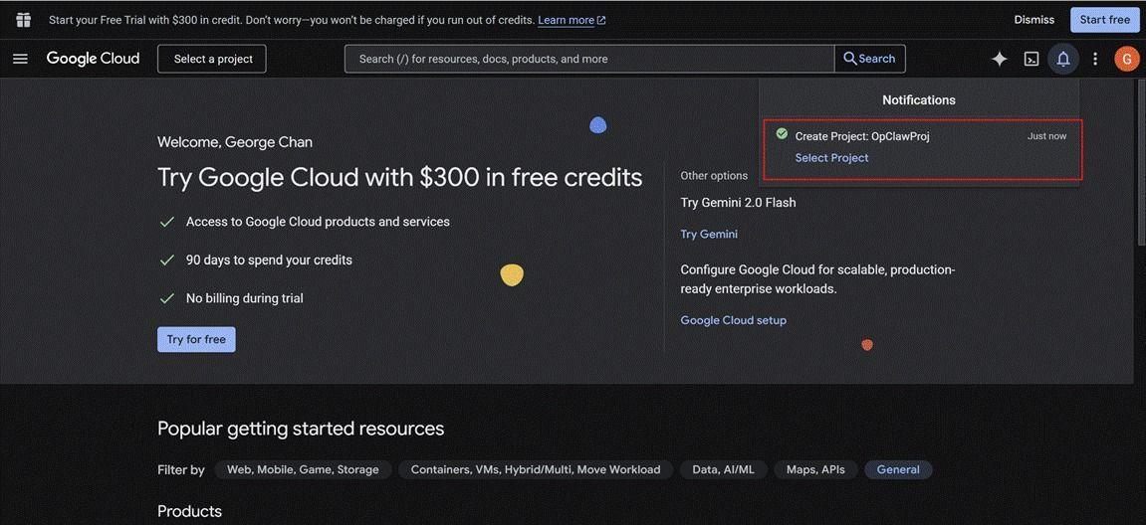
Figure 36. Enabling a selected Google API service. Click “Enable” to activate the API for use within the current project.
Navigate to API & Services / Enabled APIs & series
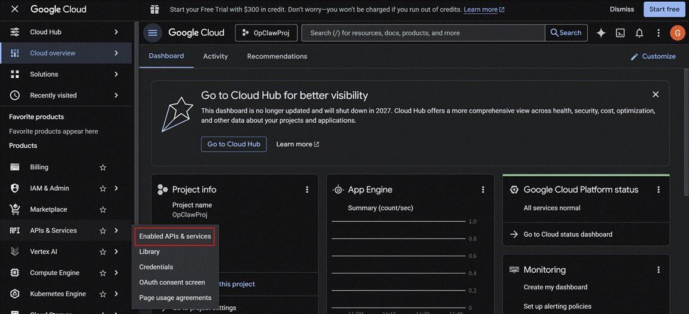
Figure 37. The OAuth consent screen configuration page. Set the application name, user support email, and developer contact information.
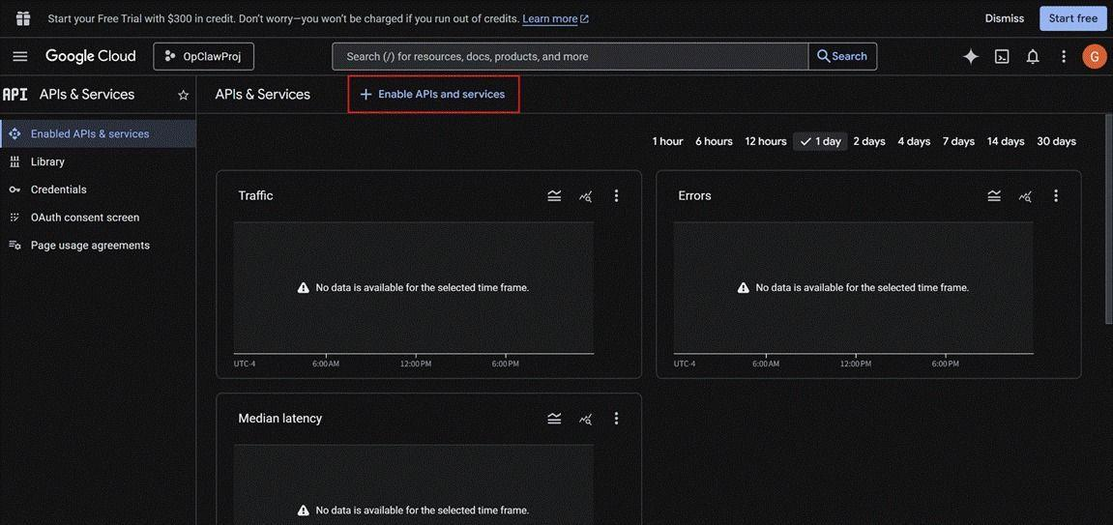
Figure 38. Configuring OAuth scopes. Add the required permission scopes corresponding to the Google services that OpenClaw will access on behalf of the user.

For each Google service that the agent should be able to access, locate the corresponding API in the library and enable it.(So far Gog only supports five) Common services for productivity automation include:
Gmail API: Enables reading, sending, and managing email messages
Google Calendar API: Enables creating, modifying, and querying calendar events
Google Drive API: Enables file upload, download, and management operations
Google Sheets API: Enables reading and writing spreadsheet data
Google Docs API: Enables document creation and editing operations

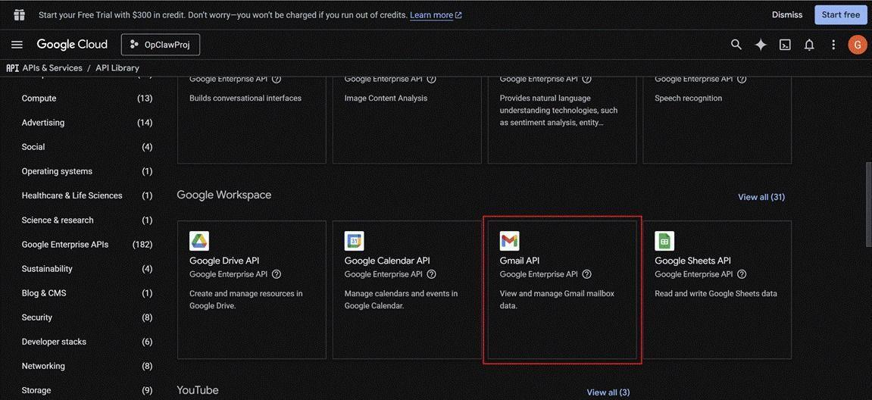
Figure 39. The OAuth credentials creation page. Select “OAuth client ID” as the credential type and configure the application type as “Desktop app”.
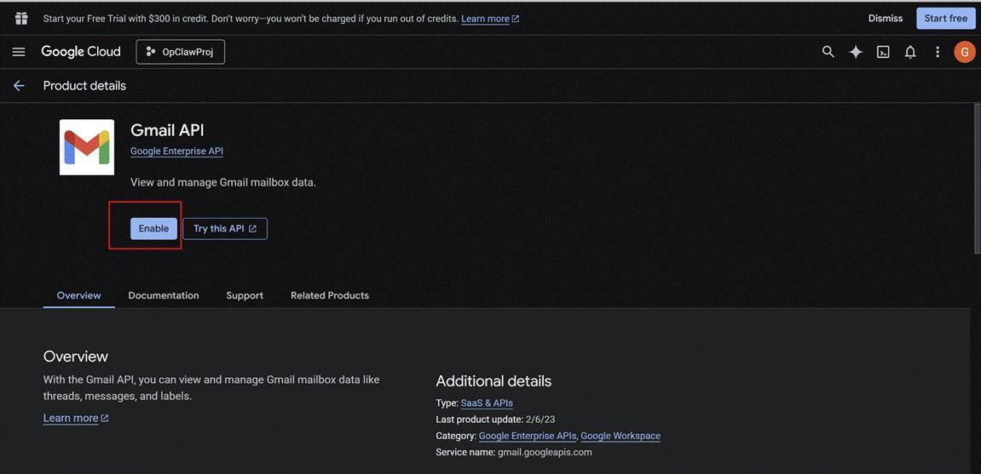
Figure 40. The generated OAuth 2.0 Client ID and Client Secret. Download the credentials JSON file and store it securely — this file will be used to authorise OpenClaw’s access to Google services.
Once all required service APIs have been enabled in the Google Cloud console, proceed by clicking the button shown below to finalise the OAuth consent screen configuration.
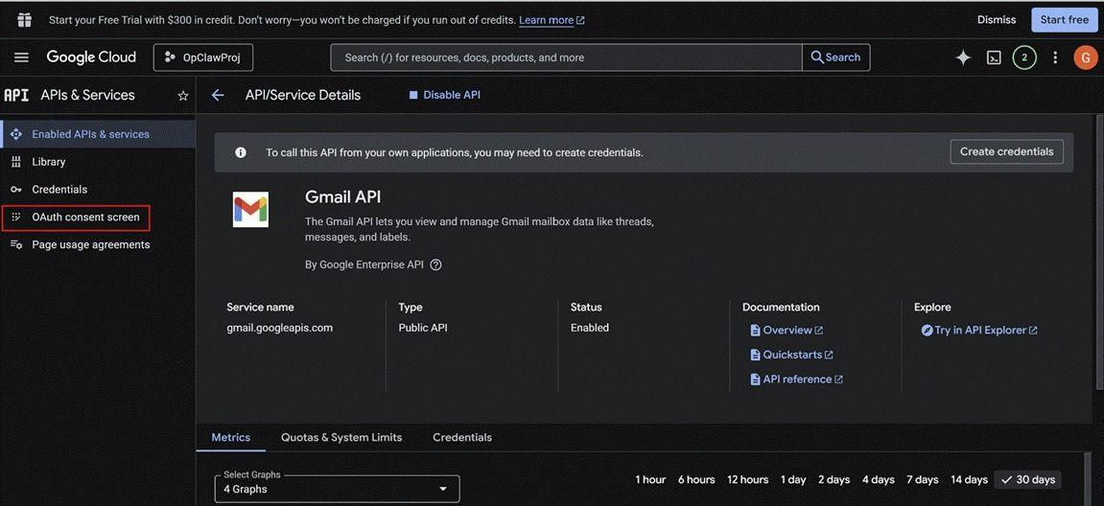
Figure 41. The OAuth consent screen publishing confirmation. Click “Publish App” to allow the credentials to be used outside of test mode.
By default, OAuth applications configured with "External" user type operate in testing mode, which limits access to explicitly listed test users and displays a warning during the authorization flow indicating that the application is unverified. For production deployments or to remove these restrictions, the application must be published.
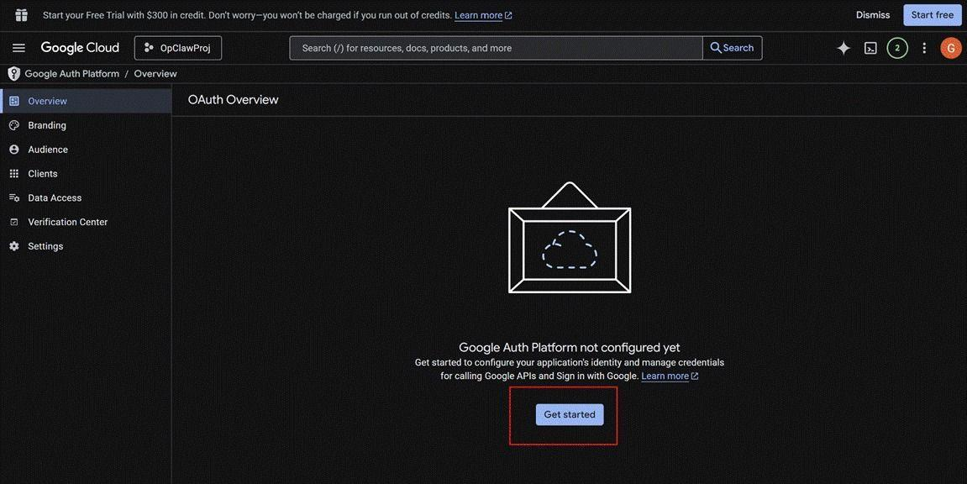
Figure 42. Completion of the OAuth consent screen setup, confirming that the application is published and the credentials are ready for use.
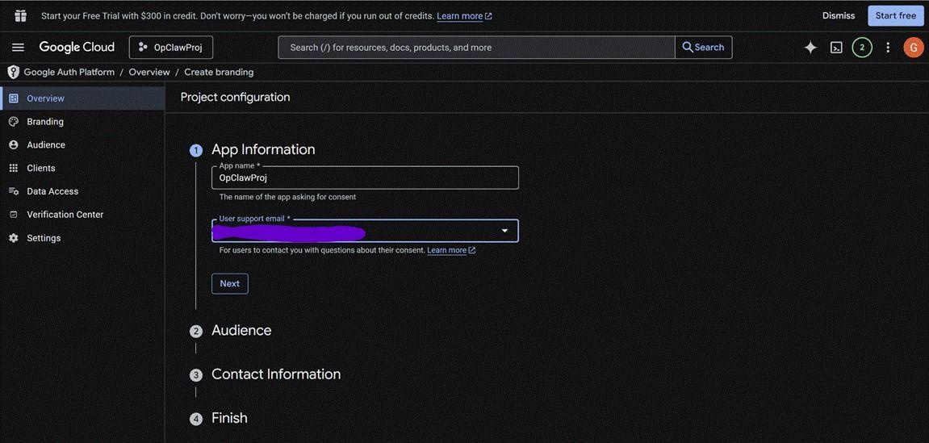
Figure 43. The final Google Cloud credentials overview, confirming that the OAuth 2.0 Client ID has been successfully created and is listed as an active credential for the project.
Follow the on-screen prompts to complete the OAuth consent screen setup. When prompted for the user type, select “External” to allow the OpenClaw application to authenticate with any Google account.
Once finished, download the JSON file, upload it to your Lightsail instance, and use OpenClaw to verify it.
Step 10.C — Implementations
Once OpenClaw has access to your Google suite, explore its functionality using the chat agent. For example, type in the chatbox: “Add a dinner at Ryan’s next Saturday night,” then check your calendar—it should appear there.
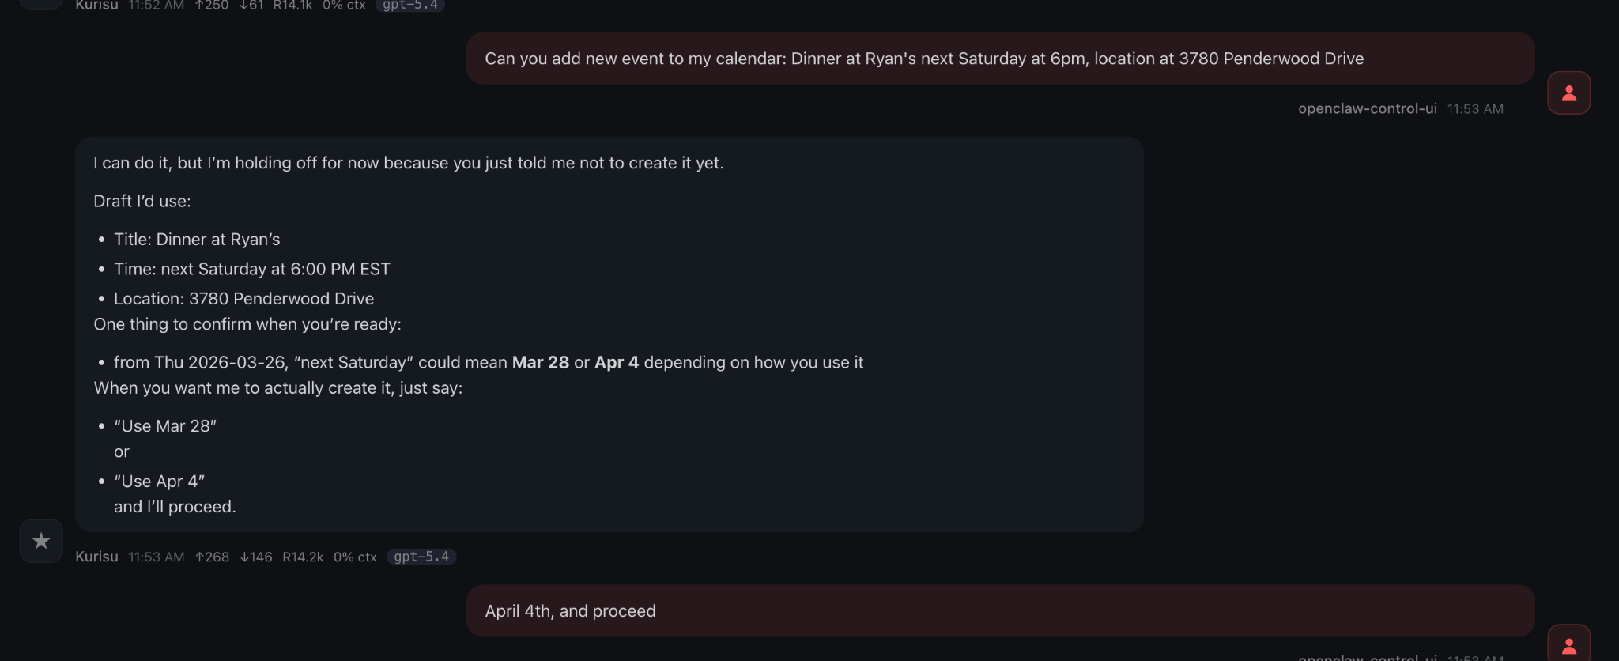
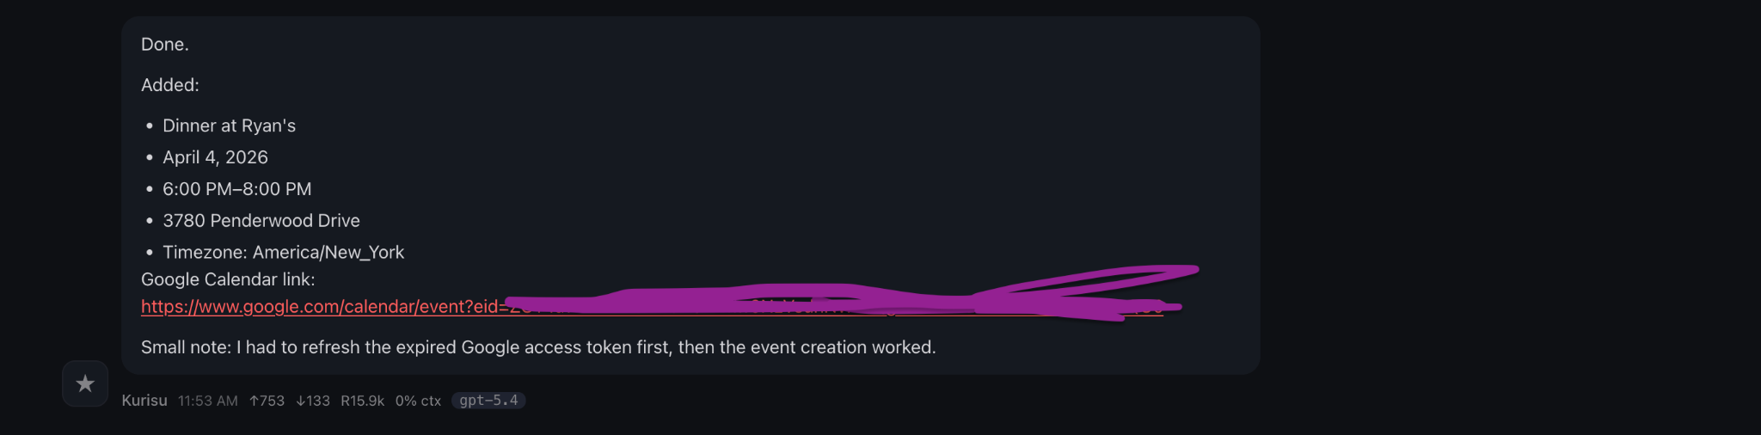
Figure 44.The screenshot shows the OpenClaw chat interface where the user requests to add a calendar event. The agent generates a draft with event details (title, time, and location) and asks for clarification on the exact date before proceeding. The user then confirms the date (“April 4th”), indicating readiness to create the event.
A new event pops up in my calendar without human intervention.


Step 10.C — Configuring Personal Daily News Report via Telegram
It’s important to stay on top of the latest developments in AI to remain competitive and informed. By aggregating RSS feeds from major AI companies and trusted tech sources, you can build a personalized stream of high-quality updates. This helps you quickly identify key trends, breakthroughs, and market shifts—allowing you to make better decisions, spot opportunities early, and stay aligned with the direction of the industry.

Run:
Read these RSS feeds and create a concise Chinese AI news briefing focused on the most important global AI news.
Requirements:
Prioritize by importance, not by publication order
Focus on major launches, big tech announcements, funding, regulation, enterprise adoption, and meaningful research
Ignore low-value or repetitive stories
Organize into: Headlines, Business & Market, Products & Technology, Policy & Regulation, Research & Frontier AI
For each story include exactly one sentence with: Title, Source, Date, Brief Summary, and Why It Matters
End with Key Signals
Keep the whole briefing concise and readable for Telegram
RSS feeds:
https://techcrunch.com/category/artificial-intelligence/feed/
https://www.theverge.com/rss/ai-artificial-intelligence/index.xml
https://feeds.arstechnica.com/arstechnica/technology-lab
https://www.wired.com/feed/tag/ai/latest/rss
https://www.fastcompany.com/section/ai/rss
https://www.cnbc.com/id/10001147/device/rss/rss.html
https://www.reutersagency.com/feed/?best-topics=technology
https://www.ft.com/artificial-intelligence?format=rss
Sample output:
